Mysql管理实战

# 常用管理命令

## 1.启动和关闭

/etc/init.d/mysql start/stop

[root@mysql-db-server ~]# ps -ef|grep mysql|grep -v grep

root 2286 1 0 16:33 pts/0 00:00:00 /bin/sh /apps/mysql/bin/mysqld_safe --defaults-file=/data/3306/my.cnf

mysql 3080 2286 0 16:33 pts/0 00:00:00 **/apps/mysql-5.5.48/bin/mysqld** --defaults-file=/data/3306/my.cnf --basedir=/apps/mysql --datadir=/data/3306/data --plugin-dir=/apps/mysql/lib/plugin --user=mysql --log-error=/data/3306/mysql_3306.err --open-files-limit=8192 --pid-file=/data/3306/mysql.pid --socket=/data/3306/mysql.sock --port=3306

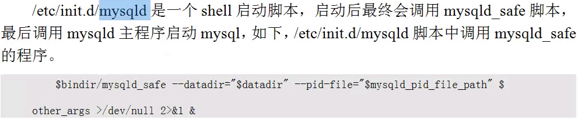

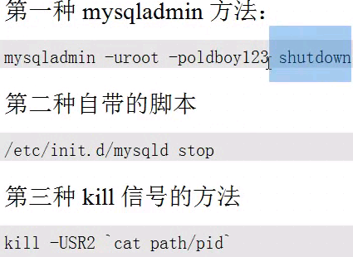

忽略空格

执行敏感命令的时候，在命令前面加上一个空格。

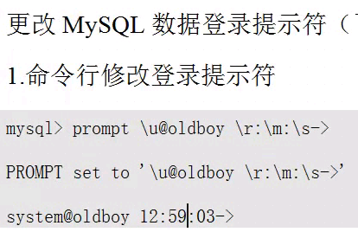

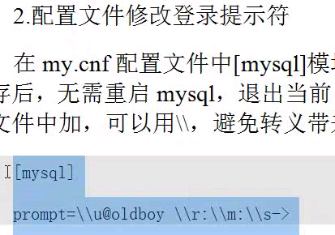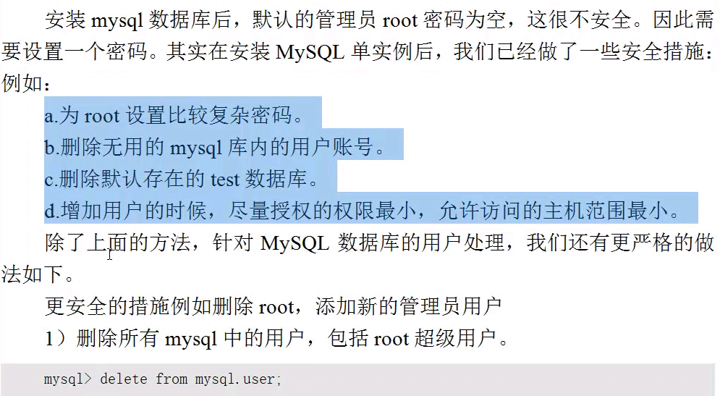



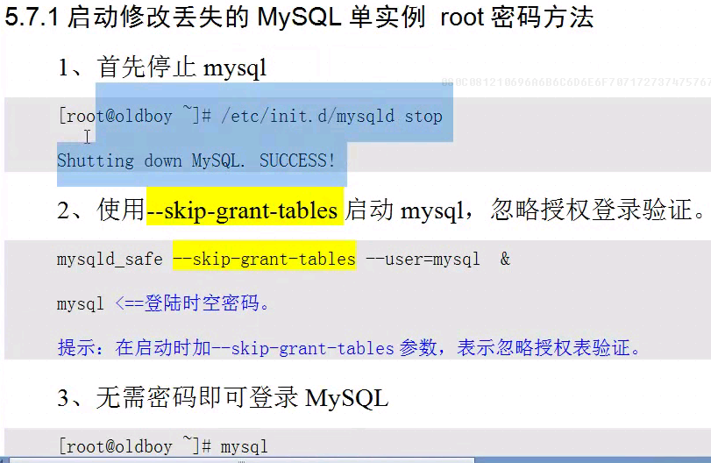





## 查看授权



## char和varchar 的区别

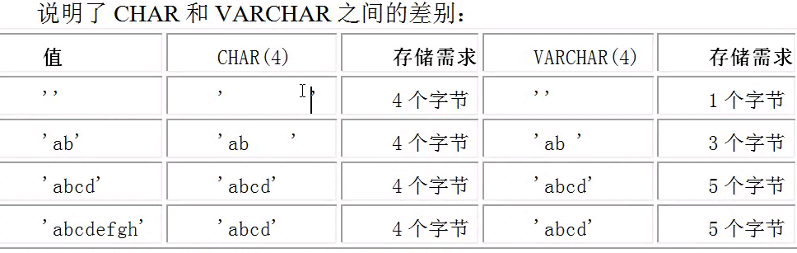

## 建表语句示例：

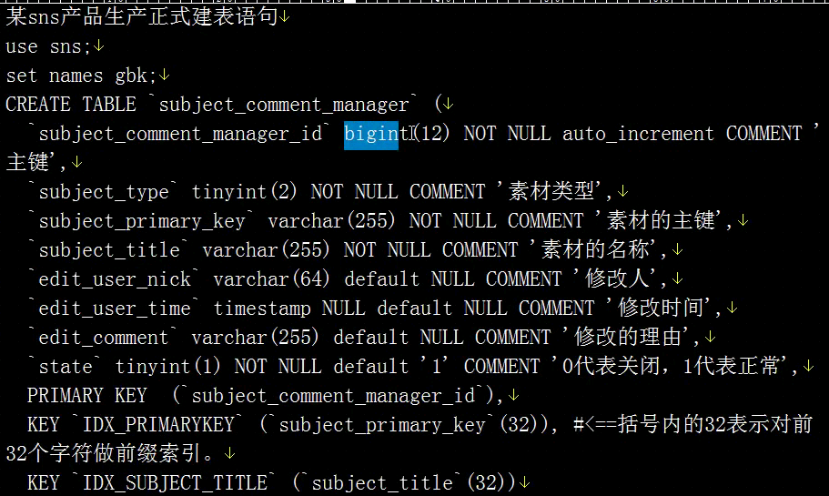



## 抓慢查询：

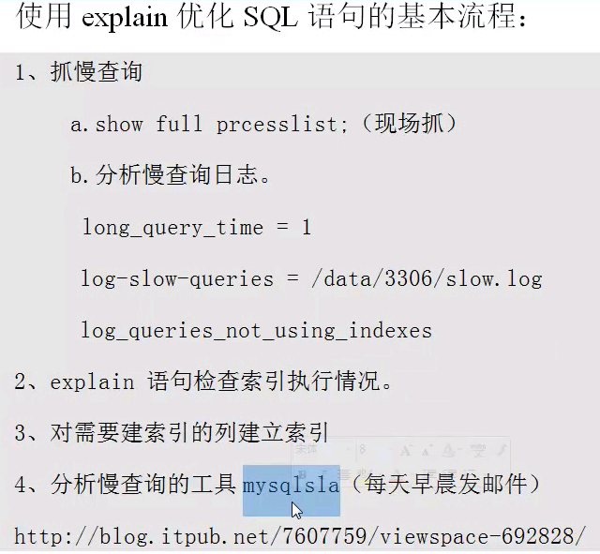

分析工具： mysqlsa



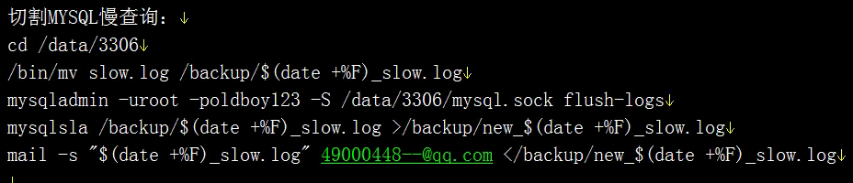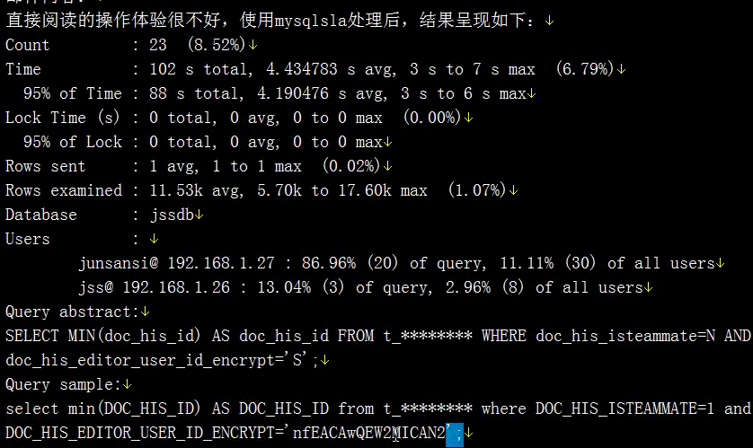

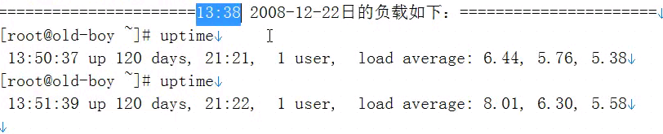

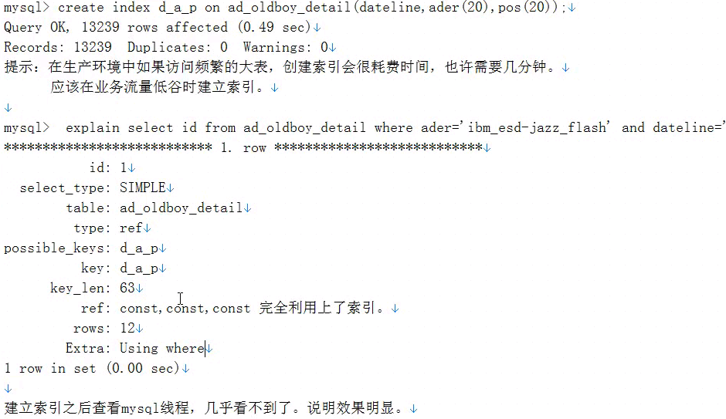

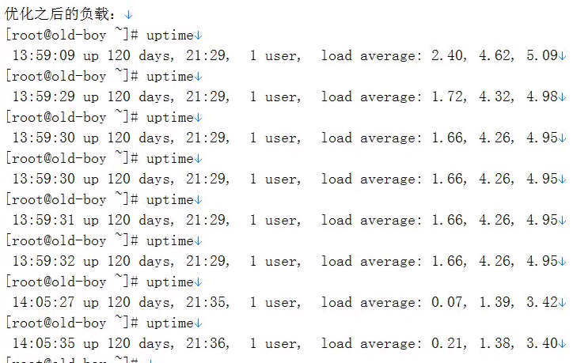

## show profiles;

mysql> select @@profiling;

+-------------+

| @@profiling |

+-------------+

| 0 |

+-------------+

1 row in set (0.00 sec)

mysql> set profiling = 1;

Query OK, 0 rows affected (0.00 sec)

mysql> select @@profiling;

+-------------+

| @@profiling |

+-------------+

| 1 |

+-------------+

1 row in set (0.00 sec)

mysql> select host,user,password from mysql.user;

+----------------------------------------+------+-------------------------------------------+

mysql> show profiles;

+----------+------------+-------------------------------------------+

| Query_ID | Duration | Query |

+----------+------------+-------------------------------------------+

| 1 | 0.00145600 | select @@profiling |

| 2 | 0.00036100 | select host,user,password from mysql.user |

+----------+------------+-------------------------------------------+

2 rows in set (0.01 sec)

mysql> show profile for query 2;

+----------------------+----------+

| Status | Duration |

+----------------------+----------+

| starting | 0.000099 |

| checking permissions | 0.000018 |

| Opening tables | 0.000039 |

| System lock | 0.000023 |

| init | 0.000021 |

| optimizing | 0.000004 |

| statistics | 0.000012 |

| preparing | 0.000008 |

| executing | 0.000003 |

| Sending data | 0.000085 |

| end | 0.000011 |

| query end | 0.000007 |

| closing tables | 0.000008 |

| freeing items | 0.000017 |

| logging slow query | 0.000003 |

| cleaning up | 0.000003 |

+----------------------+----------+

16 rows in set (0.00 sec)

mysql>

mysql> help show profile;

## 中文不乱码（UTF-8）：



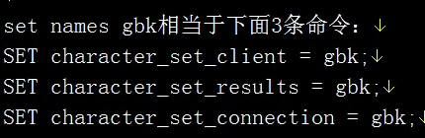

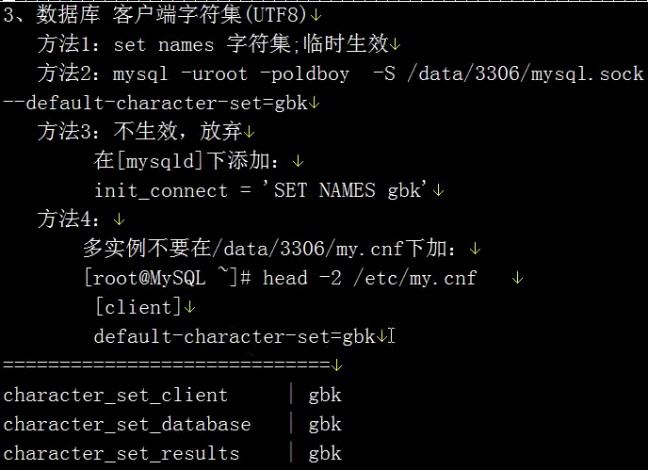

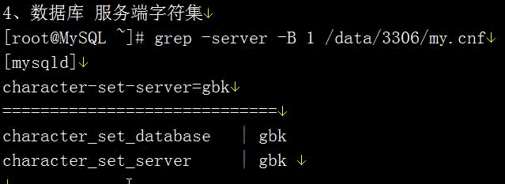

## 生产环境修改数据库字符集：



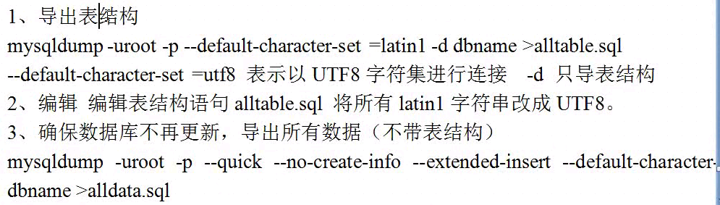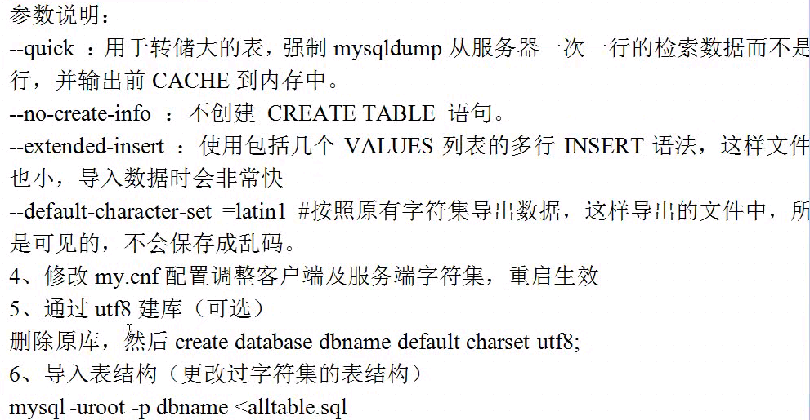



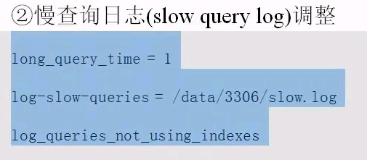

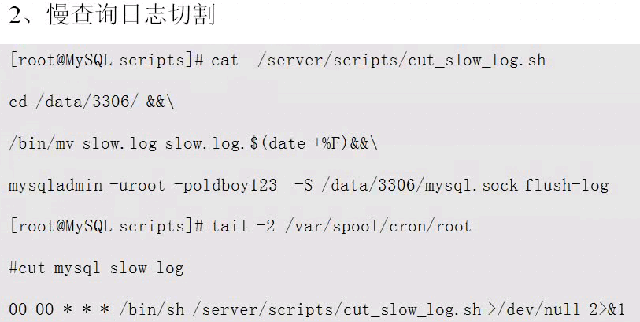

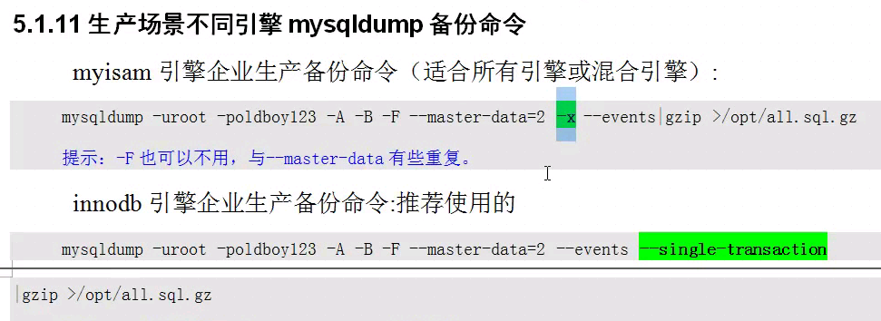



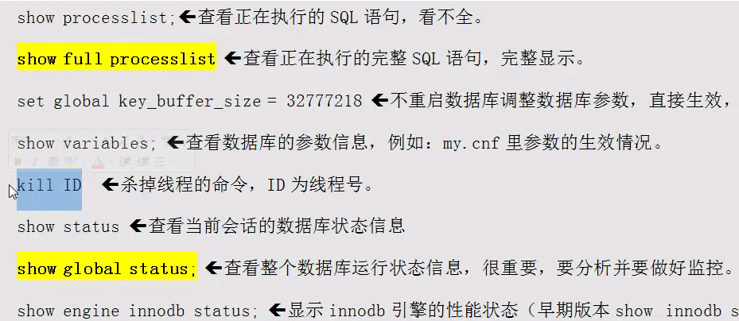

## mysqladmin

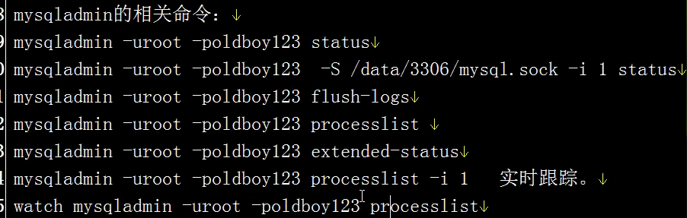



## mysqlbinlog –d

只显示某个库的日志信息：

mysqlbinlog -d DATABASE mysql-bin.000002 |egrep -v "^#|--|/|^$|\*|BE"

位置截取：

